Java Application: Step-by-Step Implementation and Output
GitHub: https://github.com/aliemarie1989/Unit-10-MPL-Lab.git
Step 1: Setting Up the Java Project
The project setup involves creating a new Java project in the NetBeans IDE. The following steps were taken:
1. A new project named 'Unit 10 MPL Lab' was created in NetBeans.
2. The project structure includes source packages and a main Java class.
This class serves as the base or superclass for different types of rock samples
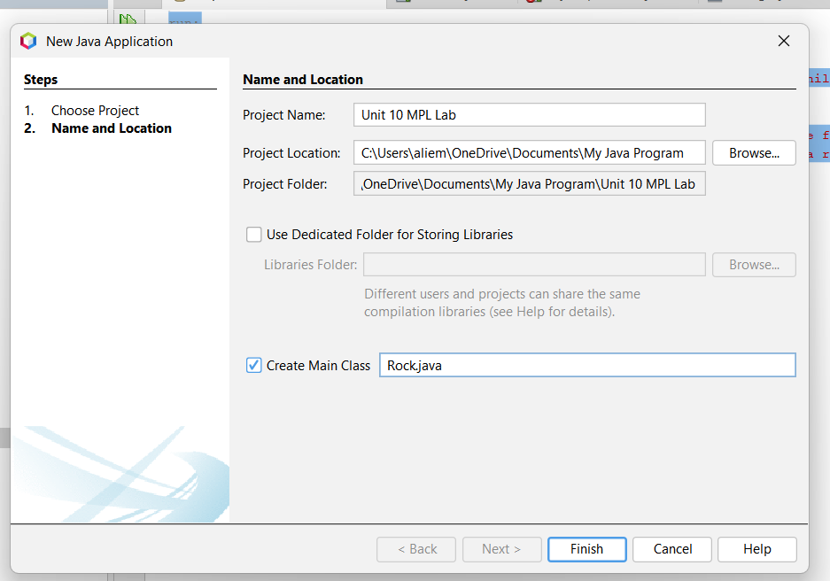
Step 2: The application includes four Java classes:
1. “IgneousRock.java”: This class specifically sets the description to indicate that it is an igneous rock formed from the cooling and solidification of magma or lav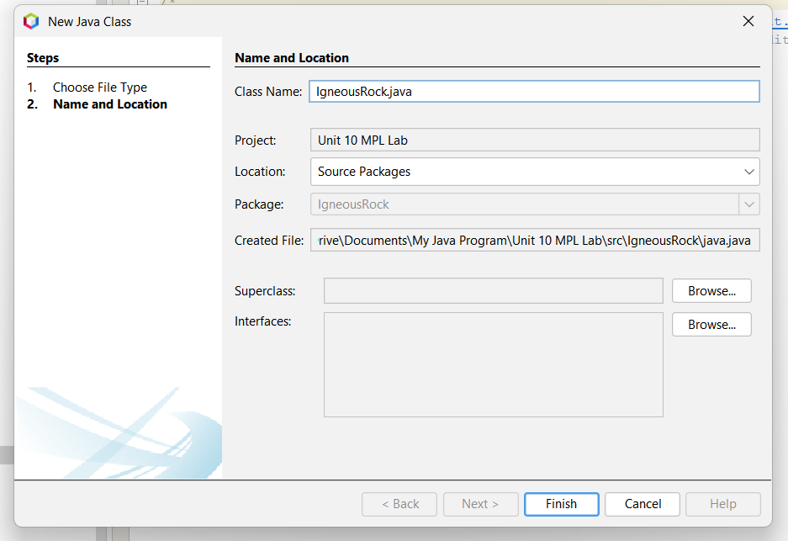
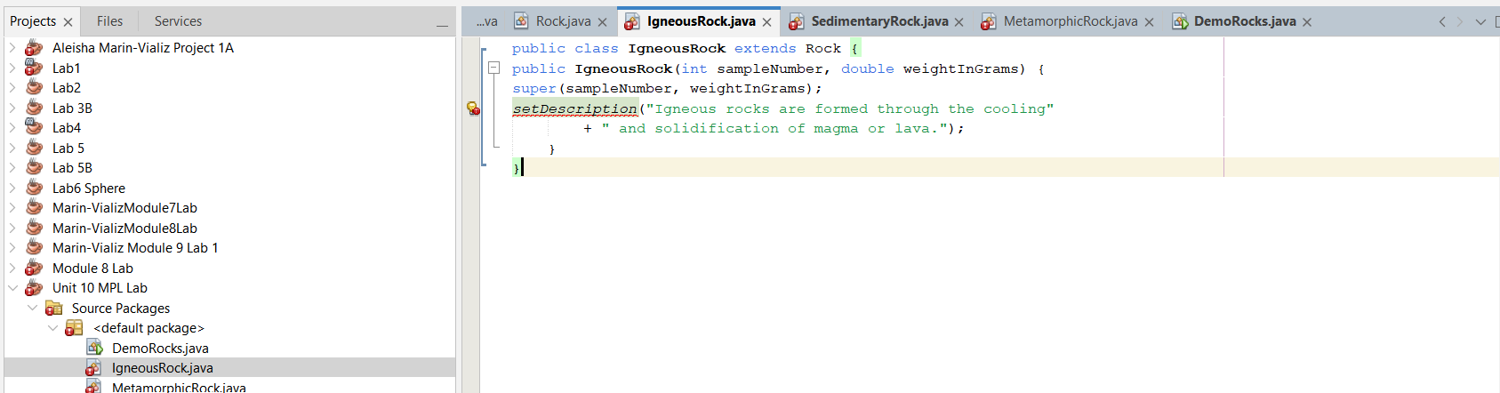
2. “SedimentaryRock.java”: This class sets its description to explain that it is a sedimentary rock formed from the accumulation and cementation of particles. 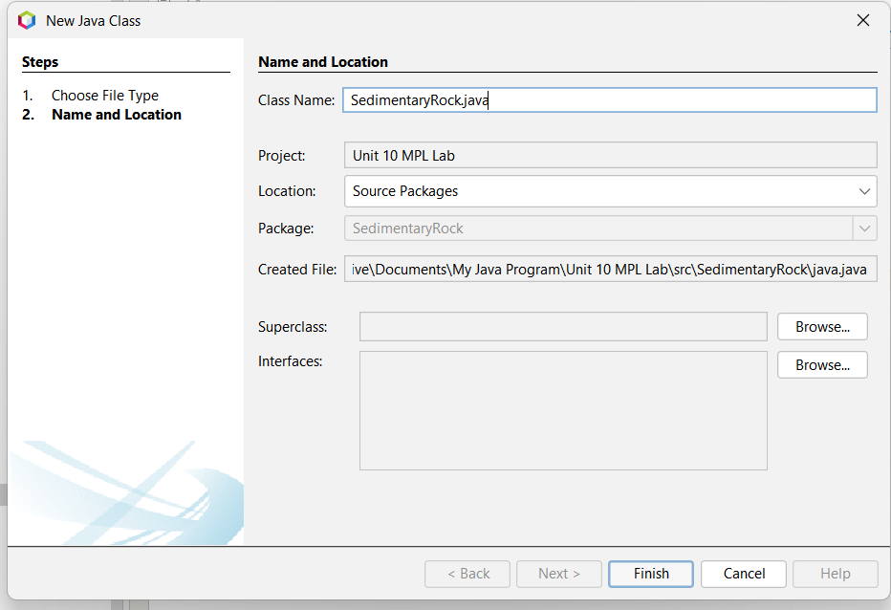
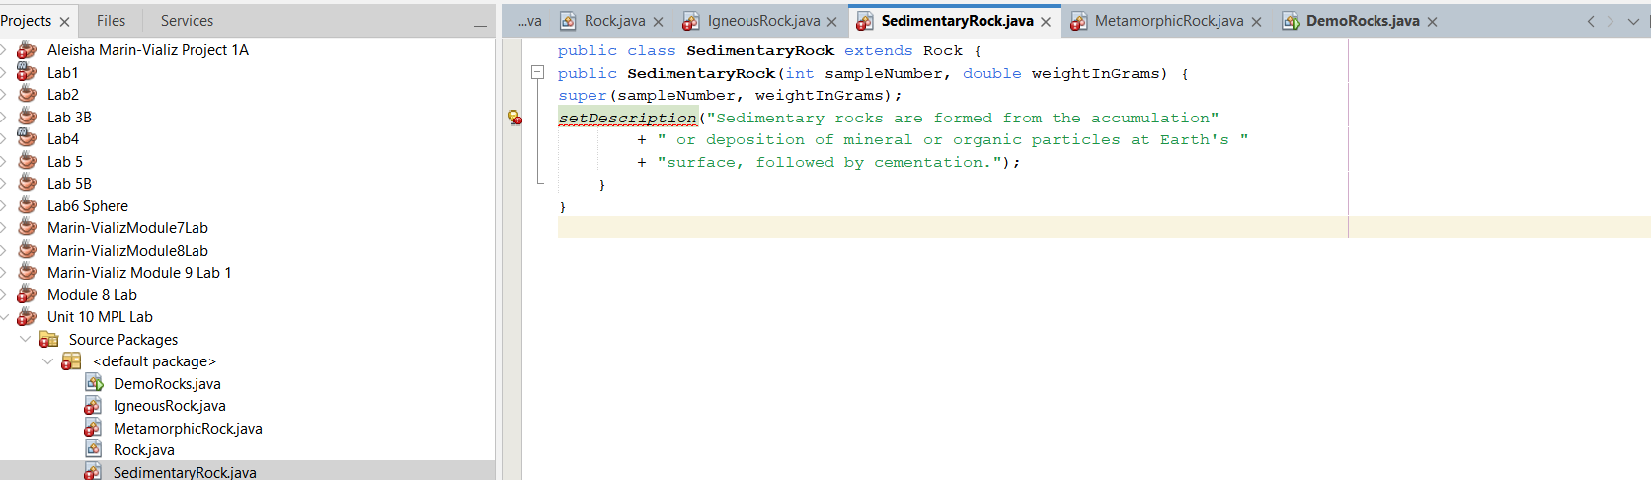

3. “MetamorphicRock.java”: This class sets its description to indicate that it is a metamorphic rock formed from existing rocks transformed by heat, pressure or chemical reaction
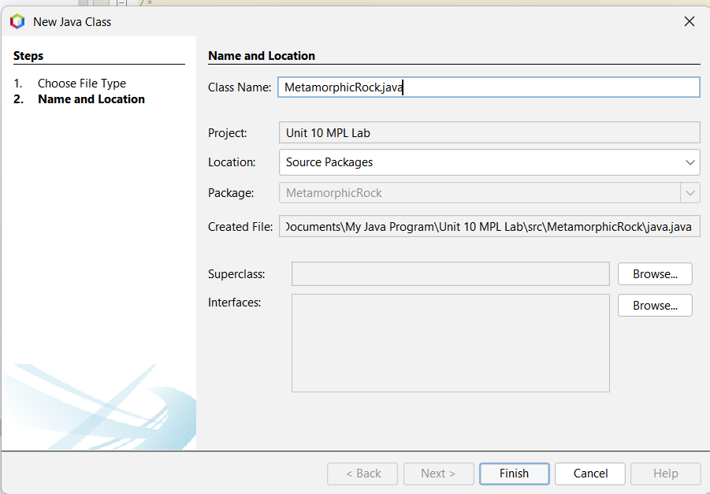

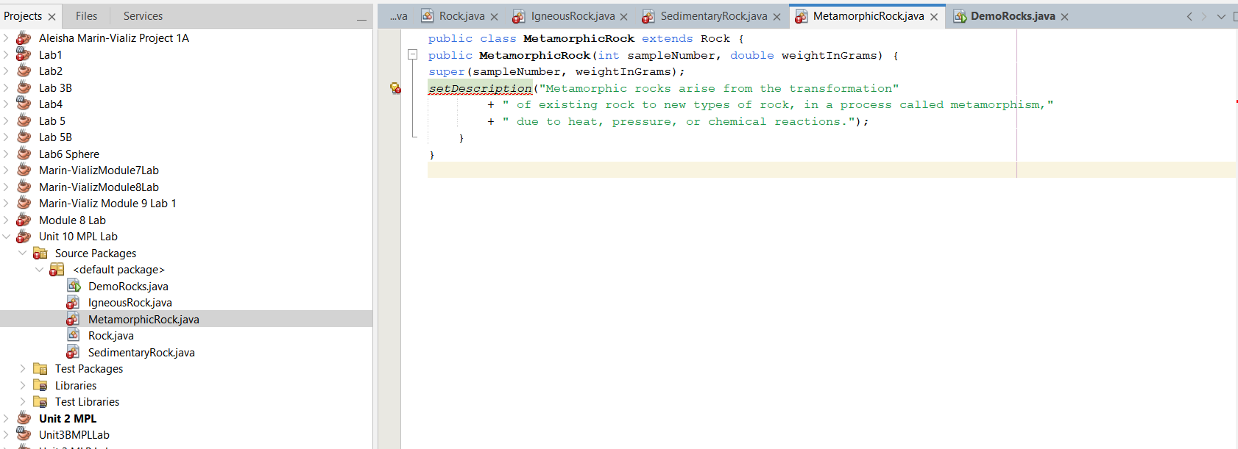

4. “DemoRocks.java”: This class it calls a method to display the details sample number, description and weight of the created rock object
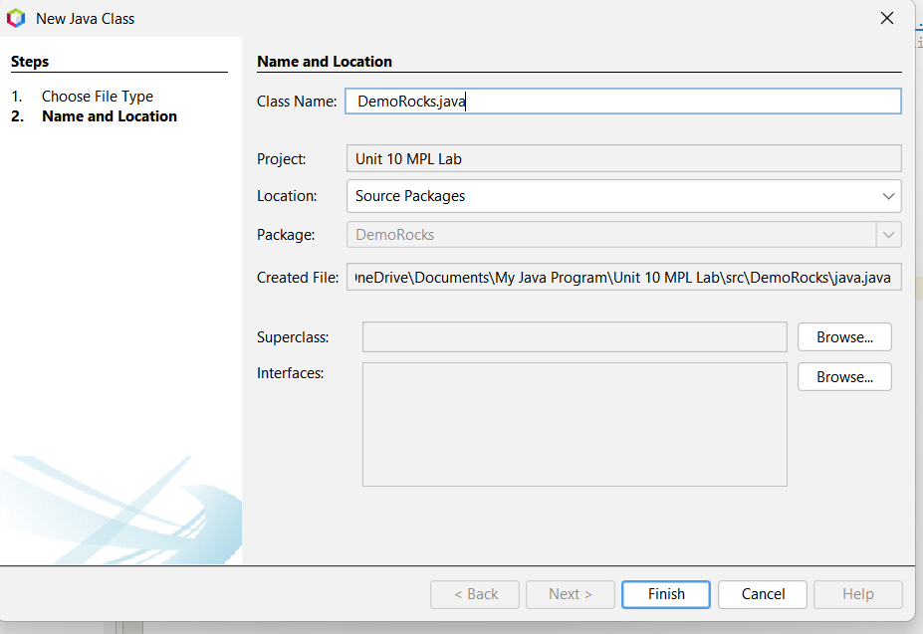
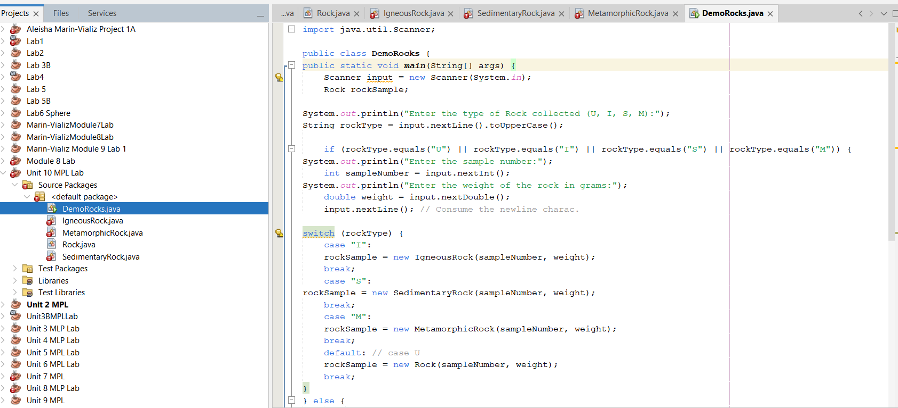

Step 3: Compiling and Running the Program
After writing the code, the program was compiled and executed in the NetBeans IDE. The output matched the expected results.
